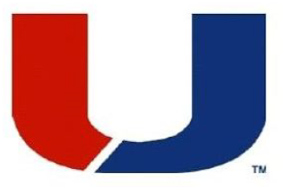

Urbandale Performing Arts Booster Club
Purchase a 2019 Marching Band Invitational Program Personal Ad

Show your support for your Instrumentalist/Crew with a personal ad in this year’s Urbandale Marching Invitational program!
  - I would like a 1/4-page ad (3 1/2” X 4 3/4”). Enclosed is $40*
  - I would like a 1/8-page ad (3 1/2” X 2”). Enclosed is $25*

Deadline to order is September 11th.

Name: ________________________________________________________________

Email: ________________________________________________________________

Phone: _______________________________________________________________

Return this form, along with your message, a picture (optional), and payment* to:
Joy Soderlund, 4479 89th Street, Urbandale, IA 50322.
*Make checks payable to Urbandale PABC.

Joy will design an ad for you and email a proof before publication. Your picture will be returned.
Questions? Call at Joy at 779-3952 or email: joy.soderlund@gmail.com

